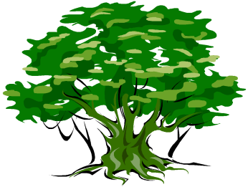
Lime Tree Surgery
321 High Road Leytonstone E11 4JT
Tel 020 8519 9914
Patients Participation Group (PPG)
Gardening Group

Notes from an informal meeting of the PPG Gardening Group that took place at Lime Tree Surgery on Friday 3rd March at 10.00 am

Those present were as follows:-
Stephen Daws, Pat Howie, George Hutton, Moira Hutton, Sue Kofi and Sharon Scarff

Stephen had arranged the informal get-together as he wanted to meet George and Moira as they had expressed an interest at being involved with the gardening group.

The group first visited the garden area in order to get an idea of the task that lay ahead. Different types of garden where discussed and it was agreed that we could grow a range of plants including some fruit and vegetables as well as flowers.

There is an apple and a pear tree already planted and these may need to be pruned as one of the first tasks. There is some litter that needs to be collected, and some weeds to get out. The paved area of the garden also needs a general tidying up. These are the type of jobs that the group could work together on as a team. It was agreed that the garden should be divided up in to imaginary “plots’’ and that would allow gardening volunteers to culture their own “plot” as well as contribute to the care of the garden overall.

After the “site visit” we went indoors to have more of a chat. There was apple, sultana and cinnamon lattice pie served with hot custard and together with the tea and coffee this helped to create a nice informal feel in the surgery. We all agreed that we should try to make the garden a little more private by fixing something to the open wire fence. Ideas came out about having hanging baskets, patio pots, patio planters and window boxes. We discussed meeting regularly on Fridays 10.00 – 1.00 and those present seemed to also like the idea of just dropping in for the odd hour or two at other times of their own choice. We agreed to make the rule of reporting to the surgery reception on arrival and departure or even having a signing in and signing out book held on reception.

Stephen informed those present that he was going to collect 3 patio planters that one of the patients had offered him. Sharon gave Stephen £50 that could be used for buying plants, seeds, tools and equipment, or anything else that we needed for the garden.

