LIME TREE SURGERY’S LOCAL PATIENT PARTICIPATION REPORT 2014

F86650

- Establish a Patient Reference Group (PRG) comprising only of registered patients

The table below reflects our current practice population and the Patient Reference Group profile by age, ethnic group and gender.

Practice population profile | Number | PRG profile | Number
AGE
Under 16 | 1628 | Under 16 | 0
17-24 | 770 | 17-24 | 0
25-34 | 1710 | 25-34 | 0
35-44 | 1287 | 35-44 | 1
45-54 | 1040 | 45-54 | 2
55-64 | 696 | 55-64 | 1
65-84 | 576 | 65-84 | 8
Over 84 | 58 | Over 84 | 0
ETHNICITY
White |  | White
British Group | 96 | British Group | 8
Irish | 50 | Irish | 0
Mixed |  | Mixed
White & Black Caribbean | 215 | White & Black Caribbean | 0
White & Black African | 107 | White & Black African | 2
White & Asian | 61 | White & Asian | 0
Asian or Asian British |  | Asian or Asian British
Indian | 173 | Indian | 0
Pakistani | 450 | Pakistani | 1
Bangladeshi | 238 | Bangladeshi | 0
Black or Black British |  | Black or Black British
Caribbean | 231 | Caribbean | 1
African | 498 | African | 0
Chinese/other ethnic group |  | Chinese/other ethnic group
Chinese | 22 | Chinese | 0
Any other | 2 | Any other | 0
GENDER
Male | 3874 | Male | 4
Female | 3871 | Female | 8

1a. The Process used to recruit to the PRG:
Leaflets
Leaflets were attached to patients’ prescriptions and were sent within a letter to the patients.
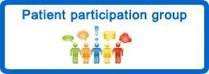

Would you like to have a say about the services provided at Lime Tree Surgery?
We would like to hear your views.
By providing your email details, we can add you to a list of contacts.
We email you every now and again to ask you a question or two.
Fill in the details on the reverse side of this leaflet and hand it back to reception or post it into the secure box and we will add your email address to a contact list.

Name:
Email address:
Postcode:
This additional information will help to make sure we try to speak to a representative sample of the patients that are registered at this practice.
Are you?
Male □ Female □
Age Group:
(Under 16 □) (17 – 24 □) (25 –34 □) (35 – 44 □) (45 – 54 □) (55 – 64 □) (65 – 74 □) (75 – 84 □) (Over 84 □)

To help us ensure our contact list is representative of our local community please indicate which of the following ethnic background you would most closely identify with?
White British Group □ Irish □
Mixed White & Black Caribbean □ White & Black African □ White & Asian □
Asian or Asian British Indian □ Pakistani □ Bangladeshi □
Black or Black British Caribbean □ African □
Chinese or other ethnic Group Chinese □ Any Other □

How would you describe how often you come to the practice?
(Regularly □) (Occasionally □) (Very rarely □)

Please note that we will not respond to medical information or questions via this email address.
The information you supply us will be used lawfully, in accordance with the Data Protection Act 1998. The Data Protection Act 1998 gives you the right to know what information is held about you, and sets out rules to make sure that this information is handled properly.

Website
Our PRG group logo was added to our website www.limetreesurgery.org.uk as a hyperlink; when patients click on the logo - they are directed to a mini questionnaire asking for details. Once this form is completed, it is then sent securely to the PRG Lead via an email.
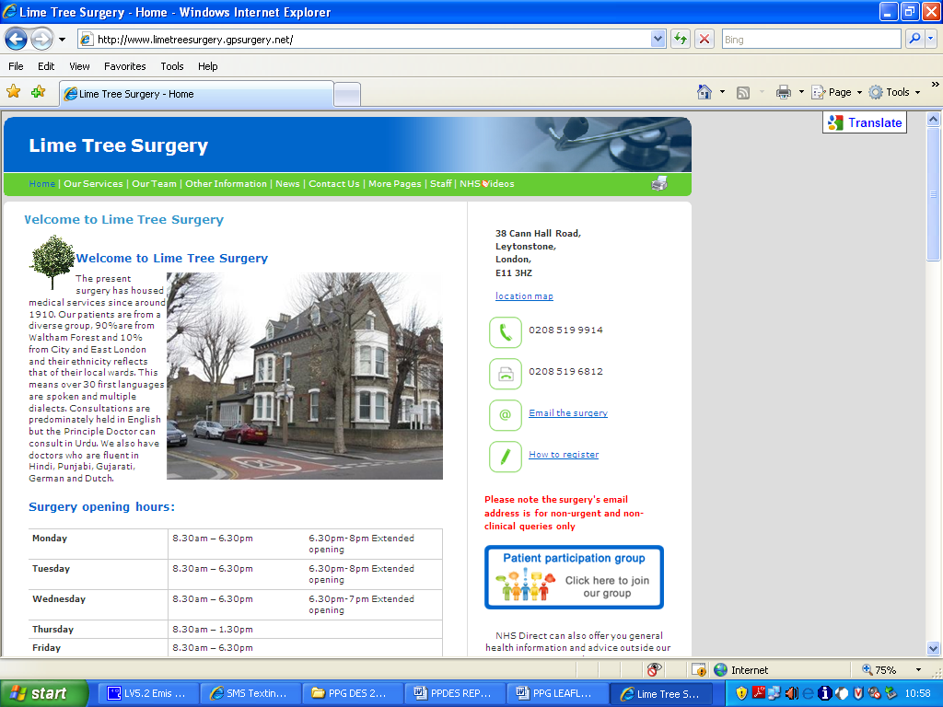

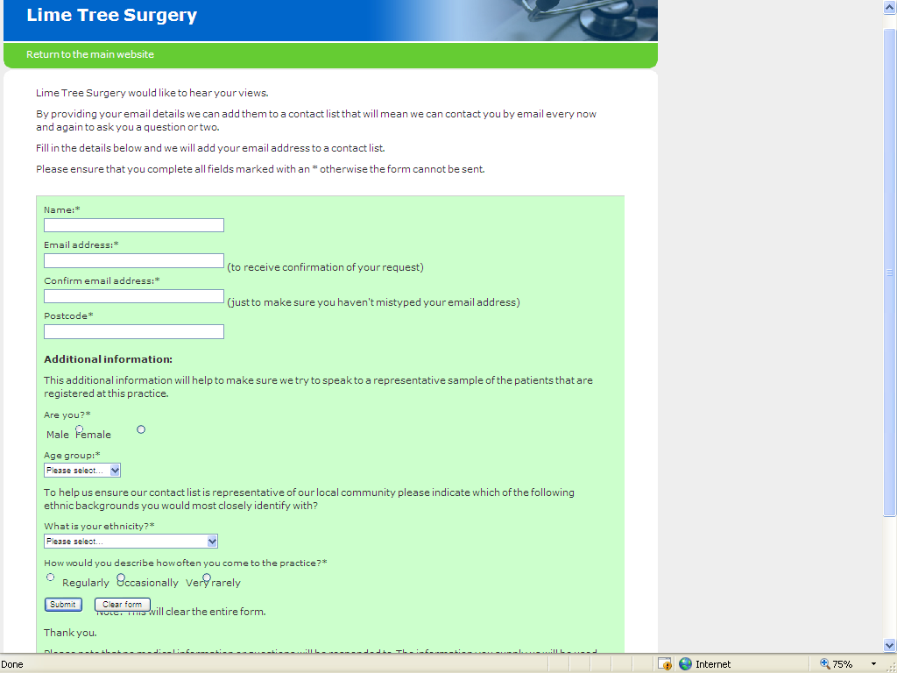

Twitter / Facebook
Unfortunately, we are unable to use this as a method, as accesses to social networking sites are denied.

Posters
Posters were put up around the surgery.

Will you help us with our own short local patient survey?

If you would like to help the surgery by:

* Agreeing what questions should be asked
* Looking at the results of the survey
* Letting us know if you agree with any changes we are able to make

…… then speak to a reception who will help you sign up

‘JAYEX’ board
Our ‘JAYEX’ board used by Doctors to call their patients was updated with a screen message to join our PRG.
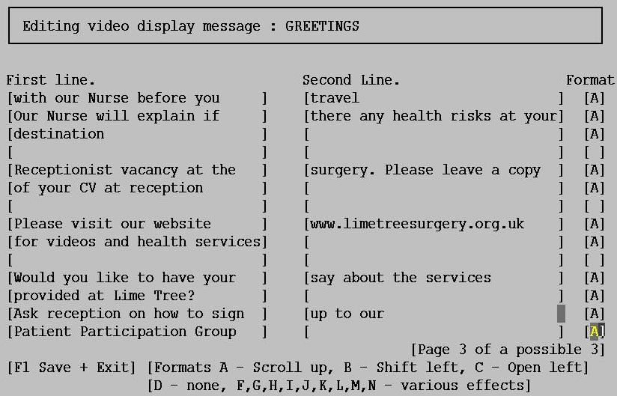

Receptionists / Doctors
Receptionists and Doctors asked patients if they would like to join as they came to the front desk or during their consultation.

Email
Email addresses are collected from registration forms. Patients who provide consent to be contacted via email are sent an invitation email to join our PRG.

Lime Tree's Patient Participation Group
LimeTreePRG (WALTHAM FOREST PCT)
Sent: 29 March 2014 14:46
To: testpatient@msn.com

We want to know what you think.

We would like to personally invite you to join our Patient Reference Group and from time to time ask you for your views. By joining our Patient Reference Group, we will ask for your input on; helping us to create a patient survey, developing our services, discussing priorities and taking action. You will have the opportunity to give and receive feedback. Most of our communication will be by email or letters. We will not be putting any demands on your time to attend meetings unless you are interested in doing so.

To sign up you can either come into the surgery and fill out a form or call 020 8519 9914 option 2 and ask to speak to the PRG Lead.

Yours sincerely

PRG Lead

Please note our Patient Reference Group is not a forum for complaints or a doctor's fan club. This email address is not to be used to make complaints, book appointments or to make urgent requests. Please contact the surgery for this on 020 8519 9914.

1b. Differences between the practice population and members of the PRG:
Our PRG does not have a representative from under 16s, 17s-24s, 25s-34s and the over 84 year olds.
We used our website as a way to encourage our younger patients to join our group, as we know young patients are more “technology savvy”. We would have liked to use social network sites such as Twitter or Facebook but we could not explore this option as the PCT have blocked us from accessing them at work.
For our older patients (over 84 year olds) we included a leaflet alongside a letter posted to them, their prescription or blood test form and encouraged our Doctors when visiting patients at home to join our patient reference group.
Our PRG does not have a representative from White Irish, White & Black Caribbean, White & Asian, Indian, Bangladeshi, African and Chinese ethnic groups. Our Doctors are from various ethnic backgrounds and we asked them to use this as a way to encourage patients whom they shared the same ethnic background with to join our PRG. Additionally, our website is equipped with Google Translate to help those with language barriers translate our website into their first language. We also use posters, leaflets, and our ‘JAYEX’ board, to reach out to all the ethnic categories.

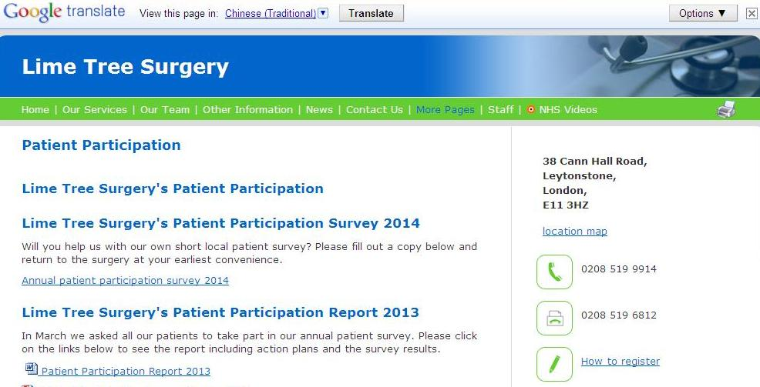

- Agree areas of priority with the PRG

2a. The areas of priority agreed with the PRG:
Care given by Nurse / Doctor
Appointments
Service from Receptionist(s)
Opening Times
Contacting the surgery
Information available to you
Your health needs

2b. How the priorities were decided:
We sent a letter to every member in our PRG with a brief summary of possible priorities and asked them to return the letter with the priorities they felt needed to be addressed. From the replies, we tallied which priorities had the most responses and these became our agreed priorities.

LIME TREE SURGERY
Dr L Ali MBChB MRCGP 38 Cann Hall Road
Dr C Kumana BSc(Hons) MBBS MRCGP DRCOG Leytonstone
Ms Pauline Boland (PA) London
Marian Wilson Nurse Practitioner E11 3HZ
Joy Glasgow Practice Manager

Tel: 020 8519 9914 Fax: 020 8519 6812

Dear Test Patient

Lime Tree Surgery would like to thank you for attending last year’s Patient Participation Group meeting on Saturday the 16th of March 2013. We were grateful for the feedback regarding the annual survey. Your comments and suggestions were taken into consideration and have we have implemented the agreed action plans.

We are planning this year’s survey and to ensure that we ask the right questions we would like to know what you think should be our key priorities when it comes to looking at the services we provide to you and others in the practice.

Out of the following options, please tick what you think are the most important issues on which we should consult our patients.

Care given by Nurse / Doctor
Appointments
Service from Receptionist(s)
Surgery opening times
Surgery’s interior
Other (please specify) ……………………

Please hand this letter into the surgery in the envelope provided.

Yours sincerely

PRG Lead

- Collate patient views through the use of a survey
3a. When was the survey conducted? How was the survey distributed?
After the priorities had been agreed with our PRG, a draft questionnaire was made using Microsoft Word. In the previous year, we used the online tool ‘Survey Monkey’ but due to budget restrictions, we were unable to upgrade our account to premium to allow for more questions.
For question templates, we used a document entitled ‘Sample Questions’ supplied by PCT.
We then sent a letter to our PRG to agree to the distribution of the survey and if they would like to make any changes.

LIME TREE SURGERY
Dr L Ali MBChB MRCGP 38 Cann Hall Road
Dr C Kumana BSc(Hons) MBBS MRCGP DRCOG Leytonstone
Ms Pauline Boland (PA) London
Marian Wilson Nurse Practitioner E11 3HZ
Joy Glasgow Practice Manager

Tel: 020 8519 9914 Fax: 020 8519 6812

Dear Test Patient

Thank you for choosing which issues you would like our annual survey to focus on. After collating the responses from all members in the Patient Reference Group, the following issues have been decided:

• Care given by Nurse / Doctor
• Appointments
• Service from Receptionist(s)
• Opening Times
• Contacting the surgery
• Information available to you
• Your health needs

We enclose a draft survey for your approval, which we will distribute to all patients.
Please indicate your approval by signing the declaration slip blow and returning it to the surgery in the envelope provided.

Yours sincerely,

Lime Tree Surgery

…………………………………………………………………………………………..

~[Title] ~[Forename] ~[Surname]

(Delete as appropriate)
• I agree to the survey being distributed to Lime Tree Surgery patients.
• I agree to the survey being distributed to Lime Tree Surgery patients but with the following suggestion(s), comment(s) or question(s).

……………………………………………………………………………………………………………………………………………………………………………………
…………………………………………………………………………………………

Signed: ……………………………… Date: …………………………………...

Yours sincerely,

PRG Lead

Once our PRG had given the go ahead for the survey to be distributed, we placed copies on reception, on our website and added a message on our ‘JAYEX’ board to ask them to fill out our survey. We did this over a 3-week period.

Website
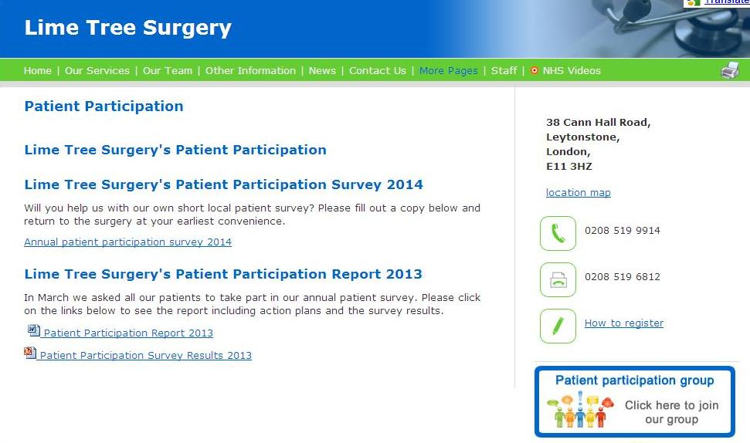
‘JAYEX’ Board
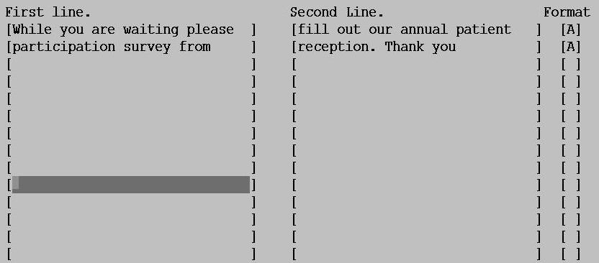

3b. Which questions in the survey relate to the priorities?
Questions 1 and 2 related to opening times
Questions 3 and 4 related to information available to you
Questions 5, 6 and 7 related to your health needs
Question 8 related to contacting the surgery
Questions 9, 10, 11, 12 and 13 related to care given by Nurse / Doctor
Questions 14, 15 and 16 related to service from Receptionist(s)
Questions 17, 18, and 19 related to Appointments

- Provide the PRG with an opportunity to discuss survey findings and reach agreement with the PRG on changes to services
4a. Describe the survey findings:
With this year’s survey, we collected representative data to see what demographic of patients are answering the survey. This data showed majority is females, with ages ranging from 25 to 54 who occasionally attend the practice and majority ethnicity being white.

The survey revealed patients find our opening times convenient but would like more evening appointments.

Our patients are happy with the information we provide as they can always pick up information from the surgery, however their preferred method of finding out information is via the telephone and our website. This was an area our PRG felt we should look into; keeping our website up to date.

This year we also wanted to look at our patient’s health needs and asked questions in the survey relating to conditions and chronic illnesses. The results showed that majority of those who answered felt they did not have a long-standing conditions but a small amount had a condition that limits their physical activity. It was explained to the PRG our premises is well equip for patients with mobility problems as we have ramp access and consulting rooms on the ground floor. Unfortunately, the data was inconclusive regarding chronic illnesses as this question was left blank on many of the surveys. It was explained to the PRG we have clinicians who specialised in, for example, Asthma. The PRG felt this was something that could be focused on by the surgery for patients who want to see the right clinician for their problem.

For the last two years, getting through on the telephone has always proven difficult for patients. Last year we decided to change our telephone message to direct patients to relevant staff member. This reflected marginally in the results but patients are still finding it difficult. The PRG expressed their understanding and felt the surgery does all they can.

Similarly, to the above, the care given by the Doctor or Nurse has been included in the survey for the last two years and the results are always positive. The PRG expressed they had no concerns regarding the care given by our clinicians. It was decided that in next year’s survey, this would not be involved.

The answers that provided a lot of discussion from the PRG were those that focused on reception. There were a few negative responses from the survey, which some members of the PRG agreed with, while others felt these answers were due to one off instances. Majority of the patients felt our receptionists were helpful, polite & courteous. It was explained to those members of the PRG that any concern regarding receptionists should be taking up directly with the practice manager.

The last area of the survey focused on appointments and gave patients the chance to have their choice in which change they would most like to see. Majority wanted more pre-bookable appointments meaning less book on the day. The PRG felt this was unreasonable and considering the demographic of patients who answered, it would be convenient for them but not for everyone. The PRG agreed the current ratio of pre-book and book on the day was reasonable.
The survey asked patients the main reason why they booked appointments which revealed it was mostly for minor ailments and running out of prescriptions. The PRG discussed the option of educating patients on the process of prescriptions and the Pharmacy First scheme.

That concludes the findings.

4b. Describe how the survey findings were reported to the PRG:
On the 29th March 2014, we gathered our PRG together and held a meeting to present the results of the survey. Through a PowerPoint presentation with graphs, the PRG were able to see which areas needed to be addressed.

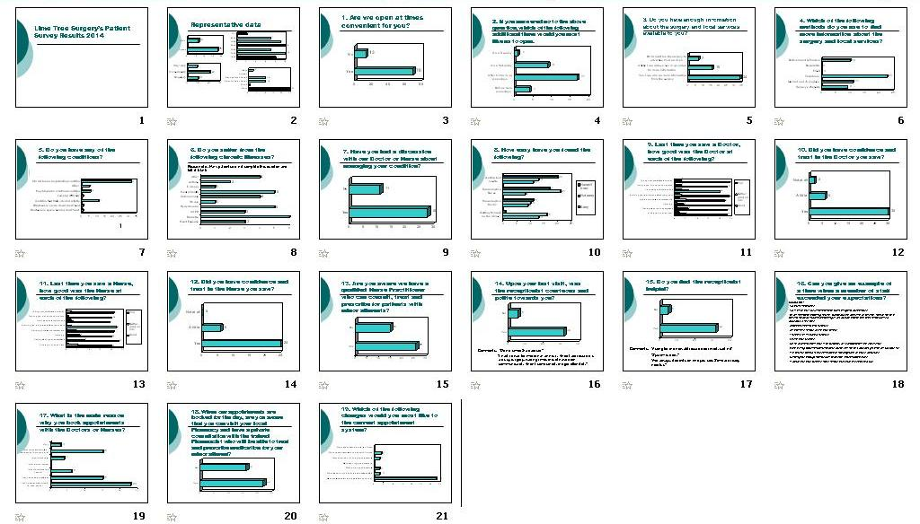

4c. Changes the practice would like to make in light of the survey findings:
We would like those patients who have concerns regarding reception staff to take this up with the Practice Manager as we are determined to provide quality of care to our patients.

4d. Recommendations from the PRG based on the survey findings:
Recommendations from our PRG focused around advertising and promoting policies and services we offer to play a part in educating patients and helping them understand how the system works.
Recommendations:
1. Utilise our website as the results showed our patients use the internet as a way to find out information on the surgery and local services.
2. Promote our clinicians specialities as this would help patients to know which clinician they should see.
3. Inform patients of the extended sessions our clinicians work
4. Educate patients on the prescription process

4e. Agreement reached with PRG on changes to be made?
Agreement was reached with our PRG on 29th March 2013

4f. Changes the practice cannot make, and the reasons why:
None

4g. Changes the practice will make:
The practice will make all the changes that the PRG and we would like put in place. Please see below for a detailed list of action plans agreed with the PRG.

- Agree an action plan with the PRG and seek PRG agreement on implementing changes

 | Action | Person responsible | Completion date | Review
1 | Advertise the surgery’s website | Lesley Briggs | April 2014 | Review will take place at the next meeting
2 | Advertise extended sessions and what times these are from | Lesley Briggs | April 2014 | Review will take place at the next meeting
3 | Advertise the Doctor’s specialities | Lesley Briggs | April 2014 | Review will take place at the next meeting
4 | Advertise Nurse Practitioner for minor ailments | Lesley Briggs | April 2014 | Review will take place at the next meeting
5 | Advertise prescription policy | Lesley Briggs | April 2014 | Review will take place at the next meeting

Update on action plan for 2012/13:
During the meeting on 29th March 2014, the PRG was updated on last year’s action plans.
Action plan 1: Advertise DNA rates. We are yet to do this. We have every intention to start this but due to changes to staff, this has proven difficult. Once the situation with staffing issues settle this will be implemented.
Action plan 2: Waiting line in reception. Due to our impending move to a new premise, we have not put this in place.
Action plan 3: Box in check-in board. We have done this by covering the sides of the check in board so no other patients can see personal information being entered on the screen.

The PRG understood the reasons as to why we were unable to implement all of last year’s action plans, however they still feel it is important that at some stage we put them into place.

- Additional Information

6a. The opening hours of the practice premises and the method of obtaining access to services throughout the core hours:
Patients are able to access our services by coming into the surgery or calling us on our telephone number, although the telephone line is closed between 1-3pm the surgery remains open. When the telephone line switches over at lunchtime, we have a message on the line that provides patients with an
emergency mobile number to call.
Opening times are
Monday 8.30am – 6.30pm
6.30pm-8pm Extended opening

Tuesday 8.30am – 6.30pm
6.30pm-8pm Extended opening

Wednesday 8.30am – 6.30pm
6.30pm-7.30pm Extended opening

Thursday 8.30am – 1.30pm

Friday 8.30am – 6.30pm

6b. The times individual healthcare professionals are accessible to registered patients under an extended hour’s access scheme:
Our nurses are accessible from 8.30am everyday until we close.
All doctors are accessible from 9.30am everyday until 6pm.
Our principle Doctor is accessible until 7.30pm on a Wednesday and two female clinicians are available until 6.30pm and 8pm every Tuesday.

- Publicise actions taken – and subsequent achievement
7a. Where the report is published:
The report is published on our website www.limetreesurgery.org.uk and a copy is in reception for patients to read while waiting to see the Doctor or Nurse. A message is on our ‘JAYEX’ board and a poster in reception, informing patient of the above.

Poster

The result from our annual survey have been published

If you would like to have a look, you can:

* Go on our website www.limetreesurgery.org.uk
* Ask reception for a paper copy but please hand this back to reception when finished

‘JAYEX’ Board
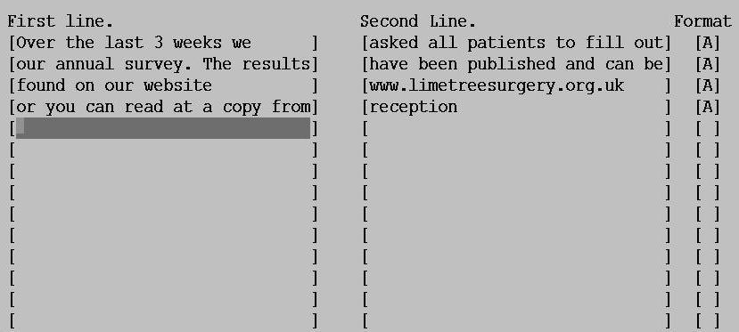

Website
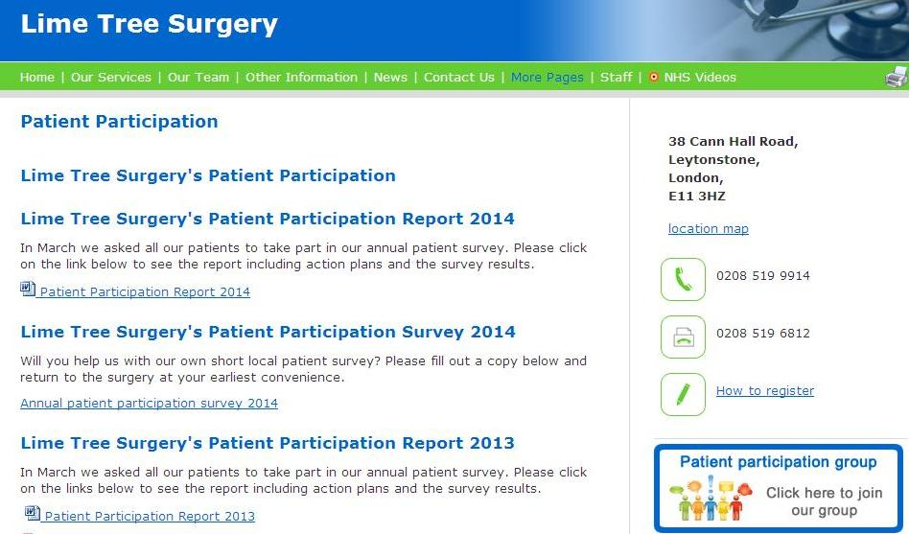

Signature of behalf of practice: Lesley Briggs

Name of signatory: Lesley Briggs

Date: 31.03.2014

