**Lime Tree Surgery New Patient Registration Form**

**Personal Information**

|  |  |  |  |  |  |  |
| --- | --- | --- | --- | --- | --- | --- |
| Title: | Mr [ ] Master [ ] Mrs [ ] Miss [ ] Ms [ ] | | | | | |
| First Name(s): |  | | | | | |
| Surname: |  | | | | | |
| Date of Birth: |  | | | | | |
| Full Address:  Full Postcode: |  | | | | | |
| Contact Numbers: | **Home** | | **Mobile** | | **Work** | |
| Email Address: |  | | | | | |
| Marital Status: | Single [ ] | Married [ ] | | Widowed [ ] | | Separated [ ] |
| Occupation: |  | | | | | |
| Main Spoken Language: |  | | | | | |

Do you consent to be contacted by email? Yes [ ] No [ ]

Do you consent to be contacted by text? Yes [ ] No [ ]

**How do you define your sexuality** (please circle):

Heterosexual Bisexual Gay/Lesbian Other

**Religion** (please circle):

Buddhist Christian Hindu Jewish Muslim Sikh None

Any other please state …………………………………………………………

**What is your Country of origin**:...............................................................................

**Which ethnic group do you feel you belong to?** (please circle)

White: A British

B Irish

C Other white (please specify)………………

Mixed: D White & Black Caribbean

E White & Black African

F White & Asian

G Other Mixed (please specify)……………….

Asian/British Asian: H Indian

I Pakistani

J Bangladeshi

K Other Asian (please specify)………………..

Black or Black British: L Caribbean

M African

N Other Black (please specify)………………...

Other ethnic categories: O Chinese

P Any Other

Not stated Q Not Stated

**NEXT OF KIN IN THE UK** ………………………………….......................................... **M [ ] F [ ]**

**CONTACT NUMBER**:…………………...……….....................................................

**RELATIONSHIP (WIFE, HUSBAND, PARTNER, CHILD, MOTHER, FATHER, FOSTER PARENT, GRANDPARENT, FRIEND, NEIGHBOUR, OTHER)………………………………………**

**REGISTERED HERE? YES [ ] NO [ ]**

**PREVIOUS GP’S NAME & ADDRESS**

...............................................................................................................................

...............................................................................................................................

______________________________________________________________________

***CURRENT MEDICATION***

***PLEASE BRING YOUR COMPUTER PRINT OUT OF REPEAT PRESCRIPTION FROM PREVIOUS GP***

***IF YOU WOULD LIKE YOUR PRESCRIPTION SENT ELECTRONICALLY, PLEASE GIVE US THE NAME AND LOCATION OF YOUR PREFERRED PHARMACY.***

_______________________________________________________________________

**ANY KNOWN ALLERGIES** (Please list any allergies you have to drugs, medicines or other substances and what happens e.g. rash/swelling.)

_______________________________________________________________________

|  |  |
| --- | --- |
| ***HEIGHT*** | *WEIGHT* |

_______________________________________________________________________

**ALCOHOL INFORMATION**

How much alcohol do you consume per week?

Please give quantities below in units:

[ ] Wine: _ _ _ _ _ _ [ ] Beer: _ _ _ _ _ _ [ ] Spirits _ _ _ _ _ _ [ ] None

________________________________________________________________________

**EXERCISE (PLEASE TICK BOX)**

|  |  |
| --- | --- |
| Exercise impossible □ | Avoids Exercise □ |
| Enjoys light exercise □ 🡪 | i.e swimming, walking  How often per week………………….. |
| Moderate exercise □ 🡪 | What type of exercise ?  How often per week………………….. |
| Aerobic exercise □ 🡪 | How often per week………………….. |

**FAMILY HISTORY HAVE ANY OF YOUR RELATIVES SUFFERED FROM THE FOLLOWING PLEASE √ YES OR NO**

**(*PLEASE STATE RELATIONSHIP)***

**RELATION YES NO**

|  |  |  |  |
| --- | --- | --- | --- |
| **Heart Disease under age 60** |  |  |  |
| **Heart Disease over the age of 60** |  |  |  |
| **Stroke** |  |  |  |
| **Hypertension** |  |  |  |
| **Diabetes** |  |  |  |
| **Cancer** |  |  |  |
| **Epilepsy** |  |  |  |
| **Asthma** |  |  |  |
| **Breast Cancer** |  |  |  |
| **Ovarian Cancer** |  |  |  |
| **Sickle Cell** |  |  |  |
| **Glaucoma** |  |  |  |
| **Mental Health problems** |  |  |  |
| **OTHER** |  |  |  |

**SMOKING INFORMATION**

Choose **ONE** column that applies to you and fill it in.

|  |  |  |
| --- | --- | --- |
| **NEVER SMOKED** | **EX-SMOKER** | **CURRENT SMOKER** |
| If you have never smoked please tick the box below:  [ ] **Never Smoked** | Age or Date you started smoking: _ _ _ _ _ _ _ _ _ _ _ _ _ _ _ _ _ _  Age or Date you stopped smoking: _ _ _ _ _ _ _ _ _ _ _ _ _ _ _ _ _ _ _  What did you smoke?  [ ] Roll ups  [ ] Cigarettes  [ ] Cigars  [ ] Pipe  [ ] Other _ _ _ _ _ _ _ _ _ _ _ _ _  Maximum you smoked per day:  _ _ _ _ _ _ _ _ _ _ _ _ _ _ _ _ _ _  What helped you stop smoking?  _ _ _ _ _ _ _ _ _ _ _ _ _ _ _ _ _ _ _ | Age or Date you started smoking: _ _ _ _ _ _ _ _ _ _ _ _ _ _ _ _ _ _ _  What do you smoke?  [ ] Roll ups  [ ] Cigarettes  [ ] Cigars  [ ] Pipe  [ ] Other _ _ _ _ _ _ _ _ _ _ _ _ _  Maximum you smoke per day:  _ _ _ _ _ _ _ _ _ _ _ _ _ _ _ _ _ _ _  Would you like to give up smoking?  [ ] YES [ ] NO  If YES would you like help to quit?  [ ] YES [ ] NO |

**YOUR PAST MEDICAL HISTORY** (Please list any serious illnesses, operations and accidents with dates PLEASE √ questions which apply to you

Do you suffer from any of the following: -

Stroke Angina Heart Attack Hypertension (High Blood) Pressure

Last BP check………………. Diastolic……./systolic……..

Diabetes Date of Annual Review……………or last follow up………….

Date of Diagnosis……………..

Epilepsy date of last fit………….Frequency of fits………………………

Asthma When did you do your last Peak Flow Reading…..…….

What was it ………..Have you been taught inhaler techniques Yes No

When was your last asthma review…………………

COPD Have you had a spirometry test? No Yes Date………..

Hypothyroidism Date of last blood test for TSH………………

Cancer when diagnosed………………..Review date…………

Mental Health problems If yes do you attend any Centres…………………...

Name of Centre……………………………………………………………………

Sickle Cell Yes No Thalassaemia Yes No

**OPERATIONS:-**

**OTHER ILLNESSES:-**

**VACCINATIONS**

When did you last have the following vaccinations?

Tetanus……………………. Typhoid……………………

Polio ……………………. Hepatitis A………………

Hepatitis B……………….. MENINGISTIS …………………..

_______________________________________________________________________

**MEN ONLY**

Are you aware of testicular cancer self-examination? Yes No

leaflet given

Have you any urinary/prostate problems? Yes No

If yes questionnaire given

**WOMEN ONLY**

**Have you had a smear test**? Yes No

IF NO DO YOU AGREE TO HAVE THE TEST DONE Yes No

CYTOLOGY LEAFLET GIVEN

IF NO - INFORMED DISSENT LETTER GIVEN/SIGNED

If Yes date of last test…………………

Result of Test………………………………………..

Where was the smear taken………………………..

Have you had any abnormal smears results…Yes No

(please tick)

GP Surgery Hospital Family Planning Clinic

Contraception Advice……………………………….

Contraceptive Advice Booklet given Yes No

*We run a Family Planning Clinic at the surgery*

Please state what method of contraception you use………………………

If using depot when is your next injection due? Date…………………………..

Have you had a Hysterectomy Yes No if yes please give date………………………..

Do you take HRT Yes No

Are you aware of self-examination of the breast Yes No

Breast awareness leaflet given

Date of your last mammogram (if appropriate) ………..

Number of births: ………….. Number of miscarriages: ………..

Number of terminations ……..

**FLU VACCINATION IF YOU ARE AGED 65 & OVER, OR IN AN AT RISK GROUP**

**i.e. DIABETIC, CHD, ASTHMA, COPD**

Do you usually have a FLU JAB YES NO

Age 65 + have you had a PNEUMOVAX VACCINE YES NO

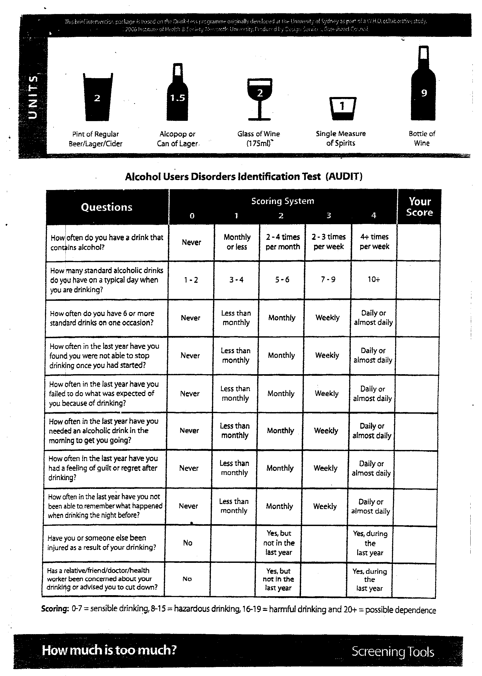

**Summary Care Record**

1. Do you wish to have a SCR created. (Please circle)

Yes / No / Need more Time

If you have answered NO or DONT KNOW to be the above question, you can either:

* Telephone the Information Line on 0845 603 8510
* Telephone PALS 020 8539 3939

**OUR STAFF WILL NOT BE ABLE TO ANSWER QUESTIONS RELATED TO THE** **SUMMARY CARE RECORD**.

2. If NO please complete an Opt Out Form available in Reception

**Should you need to discuss anything regarding your health needs please make an appointment to see either one of our doctors or practice nurses.**

**Thank you for taking the time to fill in this registration form.**



**LIME TREE SURGERY**

Dr L Ali MBChB MRCGP 321 High Road

Dr C Kumana BSc(Hons) MBBS MRCGP DRCOG Leytonstone

Dr A Effiong MRCGP London

Ms Pauline Boland (PA) E11 4JT

Ms Gloria Joseph Practice Nurse Tel: 020 8519 9914

Fax: 020 8519 6812

Practice Manager: Joy Glasgow

**CONSENT TO OBTAIN MEDICAL RECORDS**

**Please complete this form if you have had a previous doctor in the U.K.**

Full Name:………………………………………………………………….

DOB:…………………………………………………………………………

Current Address: …………………………………………………………..

………………………………………………………………………………..

Previous Address:………………………………………………………….

……………………………………………………………………………….

Previous U.K. GP Name:………………………………………………….

Address: …………………………………………………………………….

Phone: ………………………………………………………………………

Fax:…………………………………………………………………………...

I, the undersigned, hereby give my permission and request you to release full details and copies of my General Practitioners Records, both past and present and any other medical records as may be required to The Lime Tree Surgery.

I can confirm that this information is not required in respect of a claim for medical negligence.

**I AM THE PATIENT/PARENT/LEGAL GUARDIAN OF THE ABOVE** (please delete as appropriate).

SIGNATURE DATE

**SURGERY USE ONLY**

|  |  |  |
| --- | --- | --- |
|  | Initials | Date |
| Medical Card (If Applicable) |  |  |
| GSM1 Form (If Applicable) |  |  |
| Proof of address? |  |  |
| Photo ID? |  |  |
| Red Book (If Applicable) |  |  |

**PLEASE REPRINT NAME, ADDRESS, DOB, TELEPHONE NUMBERS ETC IF UNCLEAR.**

………………………………………………………………………………………………………………………………………………………………………………………………………………………………………………………………………………………………………………………………………………………………………………………………………………………………………………………………………………………………………….

………………………………………………………………………………………………………………………….

………………………………………………………………………………………………………………………….